II Lecture: Morphology, structure, classification of microorganisms (bacteria, fungi, protozoa and virus)

The purpose of the lecture. To acquaint students with the morphology, ultrastructure and systematics of different groups of microorganisms - prokaryotes (bacteria, including spirochetes, rickettsiae, chlamydia, mycoplasma and actinomycetes), eukaryotes (fungi and protozoa) and viruses.

Lecture plan:

- Morphology and ultrastructure of bacteria.
- The main morphological forms of the bacterial cell. Bacterial cell ultrastructure. Nucleoid, cytoplasm, cytoplasmic structures. Cell membrane - cytoplasmic membrane, cell wall, mucous membrane. Structural features of the cell wall of Gram-positive and Gram-negative bacteria. Acid-resistant cell wall, bacteria with defective cell wall - protoplast, spheroplast, L-shaped bacteria. Capsule, flagella, pili, spores and spore formation.
- Morphology and ultrastructure of spirochetes, rickettsiae, chlamydia, mycoplasma and actinomycetes.
1. Morphology, ultrastructure and systematics of fungi. The main forms of fungi are mycelial fungi, yeasts and yeast-like fungi. Dimorphism in fungi. Structure of mycelial fungi, hyphae, mycelium and its forms. The main types and forms of fungal spores, their importance in morphological identification. Structure of yeast and yeast-like fungi, structural features of pseudomycelium).
2. Morphology, ultrastructure and systematics of primates.
3. Morphology, ultrastructure of viruses (main differences of viruses from other microorganisms. Structural features of simple and complex viruses) and systematics.

Lecture equipment: Computer, projector, electronic slides related to the lecture.
Literature: p.1

Bacterial morphology
Bacteria (Gk. bakterion small staff) are, for the most part, unicellular organisms lacking chlorophyll. Their biological properties and predominant reproduction by binary fission relates them to prokaryotes.
The size of bacteria is measured in micrometres (mem) and varies from 0.1 mcm (Spiroplasma, Acholeplasma) to 16-18 mem (Spirillum volutans). Most pathogenic bacteria measure 0.2 to 10 mcm.
Morphologically, bacteria possess three main forms. They are either spherical (cocci), rod-shaped (bacteria, bacilli, and clostridia) or spiral-shaped (vibrios and spirilla).
Cocci (Gk. kokkos berry). These forms of bacteria are spherical, ellipsoidal, bean-shaped, and lanceolate. Cocci are subdivided into six groups according to cell arrangement, cell division and biological properties.
1. Micrococci (Micrococcus). The cells are arranged singly or irregu larly. They are saprophytes, and live in water and in air (M. agilis, M. roseus, M. luteus, etc.).
2. Diplococci (Gk. diplos double) divide in one plane and remain attached in pairs. These include: meningococcus, causative agent of epidemic cerebrospinal meningitis, and gonococcus, causative agent of gonorrhoea and blennorrhoea.
3. Streptococci (Gk. streptos curved, kokkos berry) divide in one plane and are arranged in chains of different length. Some streptococci are pathogenic for humans and are responsible for various diseases.
4. Tetracocci (Gk. tetra four) divide in two planes at right angles to one another and form groups of fours. They very rarely produce diseases in humans.
Sarcinae (L. sarcio to tie) divide in three planes at right angles to one another and resemble packets of 8, 16 or more cells. They are frequently found in the air. Virulent species have not been encountered.
Staphylococci (Gk. staphyle cluster of grapes) divide in several planes resulting in irregular bunches of cells, sometimes resembling clusters of grapes. Some species of staphylococci cause diseases in man and animals.
Rods. Rod-shaped or cylindrical forms are subdivided into bacteria, bacilli, and clostridia. Bacteria include those micro-organisms which, as a rule, do not produce spores (colibacillus, and organisms responsible for enteric fever, paratyphoids, dysentery, diphtheria, tuberculosis, etc.). Bacilli and clostridia include organisms the majority of which produce spores (hay bacillus, bacilli responsible for anthrax, tetanus, anaerobic infections, etc.).
Rod-shaped bacteria exhibit differences in form. Some are short (tularaemia bacillus), others are long (anthrax bacillus), the majority have blunted ends, and others have tapered ends (fusobacteria).

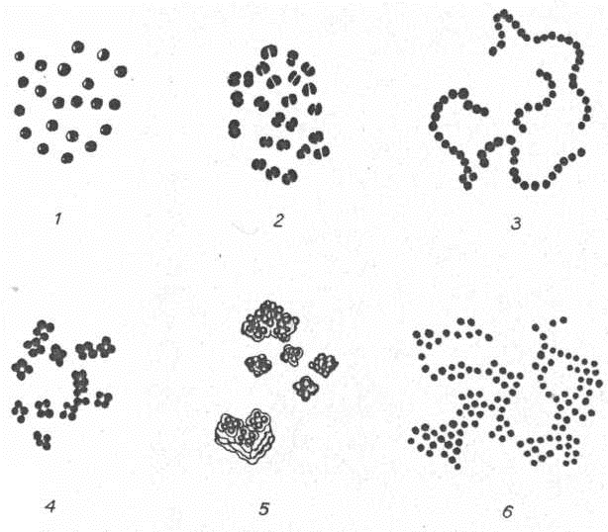

Spherical forms of bacteria
1 - micrococci; 2 - diplococei; 3 - streptococci; 4 - tetracocci; 5 - sarcinae;
6 - staphylococci

According to their arrangement, cylindrical forms can be subdivided into three groups: (1) diplobacteria and diplobacilli occurring in pairs (bacteria of pneumonia); (2) streptobacteria or streptobacilli occurring in chains of different length (causative agents of chancroid, anthrax); (3) bacteria and bacilli which are not arranged in a regular pattern (these comprise the majority of the rod-shaped forms).
Some rod-shaped bacteria have pin-head thickenings at the ends (causative agents of diphtheria); others form lateral branchings (bacilli of tuberculosis and leprosy). This is explained by the fact that in rod-shaped bacteria the ratio of surface area to volume is higher. Thus, a larger surface area is in direct contact with nutrient substances in the surrounding medium.
Spiral-shaped bacteria. Vibriones, spirochetes and spirilla belong to this group of bacteria
1. Vibriones (L. vibrio to vibrate) are cells which resemble a comma in appearance. Typical representatives of this group are Vibrio comma, the causative agent of cholera, and aquatic vibriones which are widely dis­tributed in fresh water reservoirs.
2. Spirilla (L. spira coil) are coiled forms of bacteria exhibiting twists with one or more turns. Only one pathogenic species is known (Spiril­lum minus} which is responsible for a disease in humans transmitted through the bite of rats and other rodents (rat-bite fever, sodoku).
3. Spirochetes have a helical shape and flexible bodies. Spirochetes move by means of axial.

Structure of bacterial cell
A procaryotic cell has five essential structural components: a nucleoid (DNA), ribosomes, cell membrane, cell wall, and some sort of surface layer, which may or may not be an inherent part of the wall.
Cytoplasm - The cytoplasm, or protoplasm, of bacterial cells is where the functions for cell growth, metabolism, and replication are carried out. It is a gel-like matrix composed of water, enzymes, nutrients, wastes, and gases and contains cell structures such as ribosomes, a chromosome, and plasmids. The cell envelope encases the cytoplasm and all its components. Unlike the eukaryotic (true) cells, bacteria do not have a membrane enclosed nucleus. Bacteria do not have a nucleus. They do have two types of DNA –plasmid and chromosomal. The chromosomal DNA carries most of the genetic information. Plasmid DNA forms small loops and carries extra information.

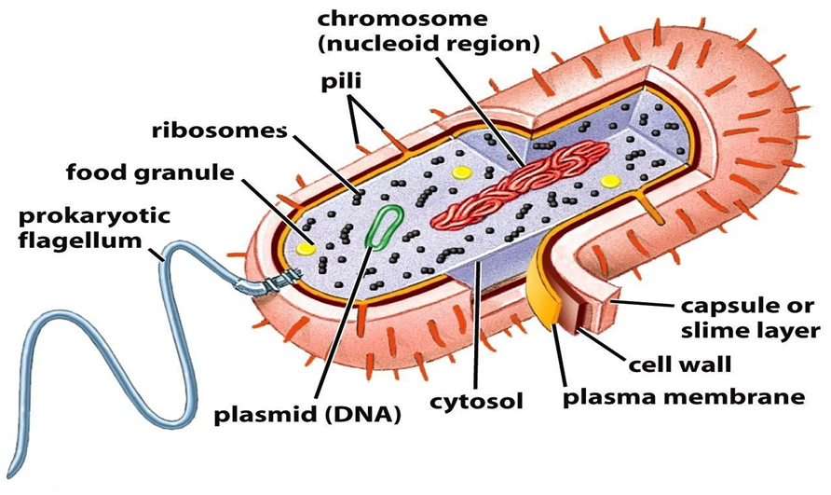
The chromosome, a single, continuous strand of DNA, is localized, but not contained, in a region of the cell called the nucleoid. All the other cellular components are scattered throughout the cytoplasm. One of those components, plasmids, are small, extrachromosomal genetic structures carried by many strains of bacteria. Like the chromosome, plasmids are made of a circular piece of DNA. Unlike the chromosome, they are not involved in reproduction. Only the chromosome has the genetic instructions for initiating and carrying out cell division, or binary fission, the primary means of reproduction in bacteria. Plasmids replicate independently of the chromosome and, while not essential for survival, appear to give bacteria a selective advantage.
Plasmids have been shown to be instrumental in the transmission of special properties, such as antibiotic drug resistance, resistance to heavy metals, and virulence factors necessary for infection of animal or plant hosts. The ability to insert specific genes into plasmids have made them extremely useful tools in the fields of molecular biology and genetics, specifically in the area of genetic engineering.
Cytoplasmic Membrane - A layer of phospholipids and proteins, called the cytoplasmic membrane, encloses the interior of the bacterium, regulating the flow of materials in and out of the cell. This is a structural trait bacteria share with all other living cells; a barrier that allows them to selectively interact with their environment. Membranes are highly organized and asymmetric having two sides, each side with a different surface and different functions. Membranes are also dynamic, constantly adapting to different conditions.
Bacterial cells are covered by a cell envelope that is composed of a cell membrane and a cell wall. The cell membrane is a phospholipid bilayer that regulates the transport of molecules into and out of the cell. This is the weak structure that would burst from the osmotic pressure without reinforcement. The cell wall is the component of the envelope that provides that reinforcement.
Nearly every genus of bacteria has a cell wall, which is a rigid, carbohydrate-containing structure that surrounds the bacterial cell. As is always the case in biology, there are a few oddballs, like the genus Mycoplasma, that have lost their cell walls, but since they are a minority, having a cell wall must be a major advantage to the bacteria.
The cell wall protects the bacterium from damage by encircling it with a tough, rigid structure. This structure is also porous. Small molecules are able to freely pass through the cell wall to the membrane, but large molecules are excluded.
The major structural component of the cell wall is peptidoglycan which is a complex molecule composed of alternating units of N-acetylglucosamine (NAG) and N-acetylmuramic acid (NAM) cross-linked by short peptides. What results is a flat, crosshatch pattern that is very strong and rigid, yet open enough for movement of particles. As you can see, peptidoglycan resembles a chain-link fence.
Nearly all bacteria have cell walls made of peptidoglycan. But there is more to a cell wall than just peptidoglycan. In nature, there are two major types of cell walls, Gram-positive and Gram-negative, each with very different structures.
The Gram negative cell envelope contains an additional outer membrane composed by phospholipids and lipopolysaccharides which face the external environment. The highly charged nature of lipopolysaccharides confer an overall negative charge to the Gram negative cell wall. The chemical structure of the outer membrane lipopolysaccharides is often unique to specific bacterial strains and is responsible for many of the antigenic properties of these strains. Many species of Gram-negative bacteria are pathogenic. This pathogenicity is often associated with the lipopolysaccharide (LPS) layer of the Gram-negative cell envelope.Gram-negative bacteria have a characteristic cell envelope structure very different from Gram-positive bacteria. Gram-negative bacteria have a cytoplasmic membrane, a thin peptidoglycan layer, and an outer membrane containing lipopolysaccharide. There is a space between the cytoplasmic membrane and the outer membrane called the periplasmic space or periplasm. The periplasmic space contains the loose network of peptidoglycan chains referred to as the peptidoglycan layer.

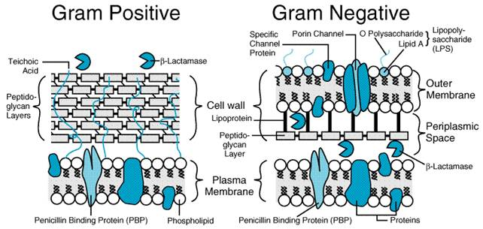
For Gram positive bacteria, which turn purple, the stain gets trapped in a thick, cross-linked, meshlike structure, the peptidoglycan layer, which surrounds the cell. Gram negative bacteria have a thin peptidoglycan layer that does not retain crystal violet stain, so the cells must be counterstained with safranin and turned red. A mnemonic device that may help is "P-Purple-Positive."

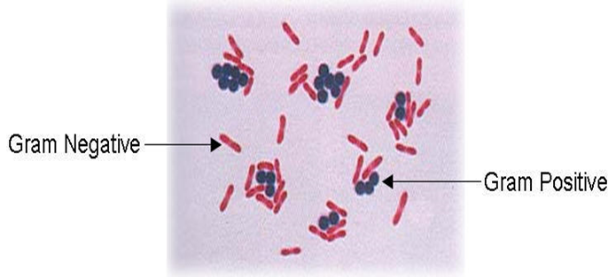

Spores
Bacterial spores are highly resistant, dormant structures formed in response to adverse environmental conditions. They help in the survival of the organisms during adverse environmental conditions; they do not have a role in reproduction. Spore formation (sporulation) occurs when nutrients, such as sources of carbon and nitrogen are depleted. Bacterial spores are highly resistance to Heat, Dehydration, Radiation and Chemicals.
An endospore is structurally and chemically more complex than the vegetative cell. It contains more layers than vegetative cells. Resistance of bacterial spore may be mediated by dipicolinic acid, a calcium ion chelator found only in spores. When the favorable condition prevail, spores germination occurs which forms vegetative cells of pathogenic bacteria.
The shape and the position of spores vary in different species and can be useful for classification and identification purposes. Endospores may be located in the middle of the bacterium (central), at the end of the bacterium (terminal) and near the end of the bacteria (subterminal) and may be spherical or elliptical.

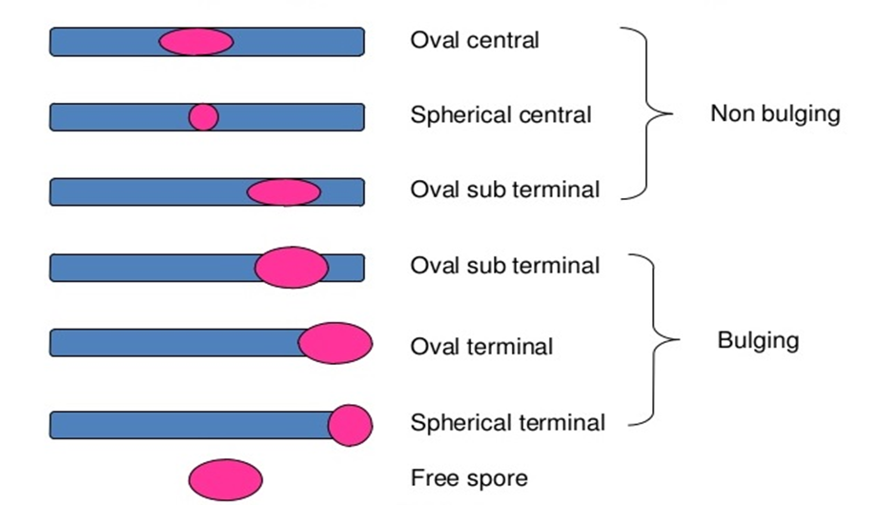

Capsule
Some species of bacteria have a third protective covering, a capsule made up of polysaccharides (Exception: The capsule of Bacillus anthracis is composed of polymerized D-glutamic acid). Capsule is gelatinous layer covering the entire bacterium. Capsule is located immediately exterior to the murein layer of gram-positive bacteria and the outer membrane of gram-negative bacteria.
Capsules play a number of roles, but the most important are to keep the bacterium from drying out and to protect it from phagocytosis (engulfing) by larger microorganisms. The capsule is a major virulence factor in the major disease-causing bacteria, such as Escherichia coli, Streptococcus pneumoniae and Klebsiella pneumoniae. Nonencapsulated mutants of these organisms are avirulent, i.e. they don't cause disease. A less discrete structure or matrix which embeds the cells is a called a slime layer or a biofilm. A type of capsule found in bacteria called a glycocalyx is a thin layer of tangled polysaccharide fibers which occurs on surface of cells growing in nature.
Mneomonics to remember capsulated bacteria- Some Killers Have
Pretty Nice Capsule
Streptococcus pneumoniae Klebsiella pneumoniae Haemophilus influenzae Pseudomonas aeruginosa Neisseria meningitidis Cryptococcus neoformans

Flagella. Investigation of bacterial motility.
Motile bacteria are subdivided into creeping and swimming bacteria. Creeping bacteria move slowly (creep) on a supporting surface as a result of wave-like contractions of their bodies, which cause periodic alterations in the shape of the cell. Swimming bacteria move freely in a liquid medium.
Flagella (singular: flagellum) are long, thin, whip-like appendages attached to a bacterial cell that allow for bacterial movement (also known as motility). Different bacterial species have different flagella arrangements, from a single flagellum to one on each end to tufts of many. The long, filament portion of the flagellum is composed of a protein called flagellin. These proteins form long chains that give the flagellum a helical shape. At the cell membrane, the flagellum gets wider and attaches to a ring of proteins known as the flagellar motor. The motor is embedded in the membrane, anchoring the flagellum. The flagella beat in a propeller-like motion to help the bacterium move toward nutrients; away from toxic chemicals.
That the flagella are made up of pro­teins the composition of which differs considerably from that of the bacterial cell proteins (keratin, myosin, fibrinogen). It has been suggested that the flagella are attached to basal granules which are found in the outlying zones of the cytoplasm.
According to a pattern in the attachment of flagella motile microbes can be divided into 4 groups (1) Monotrichous, bacteria having a single flagellum at one pole of the cell (cholera vibrio, blue pus bacillus), (2) Amphitrichous, bacteria with two polar flagella or with a tuft of flagella at both poles (Spirillum volutans), (3) Lophotrichous, bacteria with a tuft of flagella at one pole (blue-green milk bacillus, Alcaligenes faecalis), (4) Peritrichous, bacteria having flagella distrib­uted over the whole surface of their bodies (escherichia, salmonellae of enteric fever and paratyphoids A and B).
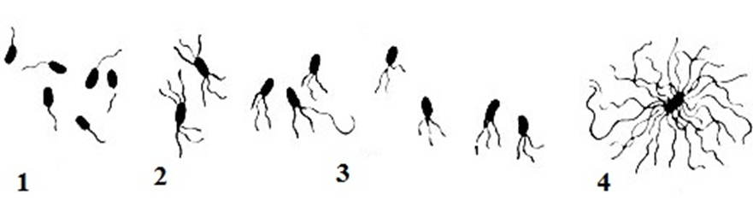

Bacterial flagella
Various types of microbes have pili (cilia, filaments, fimbriae), struc­tures which are much shorter and thinner than the flagella. They cover the body of the cell and there may be 100 to 400 of them on one cell.
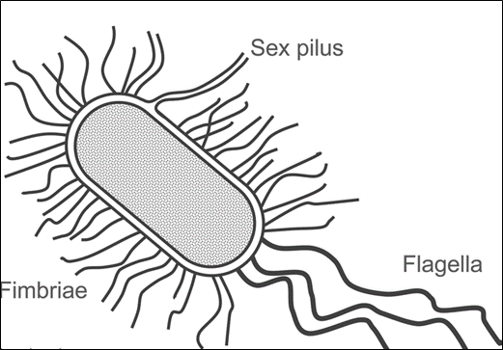
Filamentous of bacterial cell

A pilus is a thin, rigid fiber made of protein that protrudes from the cell surface. The primary function of pili are to attach a bacterial cell to specific surfaces or to other cells. Along the length of the pilus are adhesin proteins. These molecules aid in the attachment of the pilus and are specific to the target surface.
Pili can also aid in attachment between bacterial cells. Some bacteria are able to produce conjugation pili that allow for the transfer of DNA from one bacterial cell to another. Bacteria have evolved the process of conjugation as a way to increase genetic variability.
Of most interest are the F-pili within which where is a canal through which the genetic material from the donor to the recipient transferred during conjugation. It is possible that the pili contribute to the nutrition of bacteria since they greatly increase the surface area of the bacterial cell.
Closely related to pili are structures called fimbriae (singular: fimbria). These are short, filamentous structures, present in large numbers that aid in cell adherence to surfaces. A bacterium that has fimbriae is usually covered with short hair-like fibers. In contrast, pili are much longer, and a cell usually only has one or two pili. Pathogenic bacteria can have adhesins on the fimbriae that allow them to attach to the target tissues of their host.

Morphology and Ultrastructure of Spirochaetes.
Genetically spirochaetes (L. spira curve, Gk. chaite cock, mane) differ from bacteria and fungi in structure with a corkscrew spiral shape. The body of the spirochaete consists of an axial filament and cytoplasm wound spirally around the filament. No special membrane separates the nucleoid from the cytoplasm. Spirochaetes have a three-layer outer membrane. As demonstrated by electron microscopy, they possess a fine cytoplasmic membrane enclosing the cytoplasm. The spirochaetes do not possess the cell wall characteristic of bacteria, but electron microscopy has revealed that they have a thin cell wall (periplast) which encloses the cytoplasm . Spirochaetes do not produce spores, capsules, or flagella. Very delicate terminal filaments resembling flagella have been revealed in some species under the electron microscope.
In spite of the absence of flagella, spirochaetes are actively motile due to the distinct flexibility of their bodies. Spirochaetes have a rotating motion which is performed axially, a translational motion forwards and backwards, an undulating motion along the whole body of the microorganism, and a bending motion when the body bends at a certain angle.
Some species stain blue, others blue-violet, and still others — pink with the Giemsa stain. A good method of staining spirochaetes is by impregnation with silver. Staining properties (reaction to stains) are used to differentiate between saprophytic and pathogenic representatives of spirochaetes.
Classification of spirochaetes. The order Spirochaetales, family Spiro-chaetaceae includes the sprophytes (Spirochaeta, Cristispira) representing large cells, 200-500 mсm long, some of which have crypts (undulating crests); the ends are sharp or blunt. They live on dead substrates, in foul waters and in the guts of cold-blooded animals. They stain blue with the Giemsa stain.
Three pathogenic genera belong to the family Spirochaetaceae:
- Borrelia,
- Treponema,
- Leptospira.
The organisms of genus Borrelia differ from spirochaetes in that their cells have large, obtuse-angled, irregular spirals, the number of which varies from 3 to 10. Pathogenic for man are the causative agents of relapsing fever transmitted by lice (Borrelia recurrentis) and by ticks (Borrelia persica, etc.).
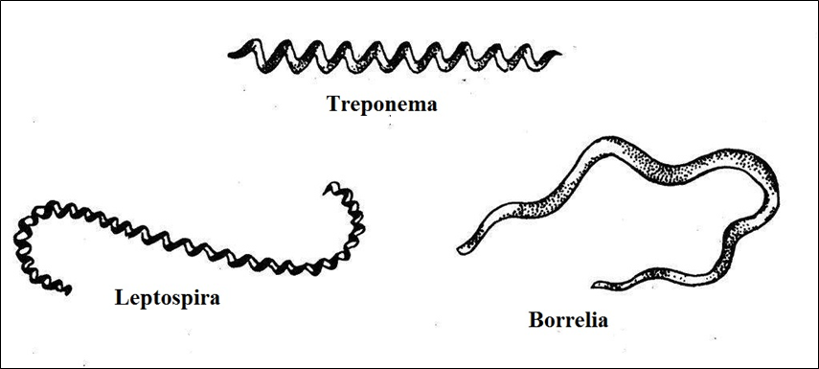
The genus Treponema (Gk. trepein turn, пета thread) exhibits thin, flexible cells with 6-14 twists. The micro-organisms do not appear to have a visible axial filament or an axial crest when viewed under the microscope. The ends of treponemas are either tapered or rounded, some species have thin elongated threads on the poles. Electron microscopy of ultrathin treponema sections revealed a thin, elastic and poorly resistant membrane composed of lipids, poliosides, and proteins. The cytoplasmic membrane lends the treponemas a spiral shape. Besides the typical form, there may be treponemas seen as granules, cysts, L-forms, and other structures. The organisms stain pale-pink with the Giemsa stain. A typical representative is the causative agent of syphilis Treponema pallidum.
Organisms of the genus Leptospira (Gk. leptos thin, speira coil) are characterized by very thin cell structure. The leptospirae form 12 to 18 coils wound close to each other, shaping small primary spirals. The organisms have two paired axial filaments attached at opposite ends (basal bodies) of the cell and directed toward each other. The middle part of the leptospirae have no axial filament. Due to the presence of the two pairs of axial filaments the leptospirae are capable of quite complex and active movement. During movement the ends of the organisms rotate rapidly at a right angle to the main part of their body. At rest the ends are hooked while during rapid rotary motion they resemble buttonholes. Secondary spirals give the leptospirae the appearance of brackets or letter S. The cytoplasm is weakly refractive.

Morphology and Ultrastructure of Rickettsiae
Rickettsiae are included in the order Rickettsiales of obligate intracellular bacteria containing DNA and RNA and are pleomorphic organisms. They live and multiply only within the cells (in the cytoplasm and nucleus) of the tissues of humans, animals, and vectors.
Coccoid forms resemble very fine, homogeneous, or single-grain ovoids about 0,5 mcm in diameter, quite often they occur as the diploforms. Rod-shaped rickettsiae are short organisms from 1 to 1,5 mcm in diameter with granules on the ends; or long and usually curved thin rods from 3 to 4 mcm in length. Filamentous forms are from 10 to 40 mcm and more in length; sometimes they are curved and multigranular filaments.
Electron microscopy and cytochemical study have shown that the rickettsiae have an inner (0,06 mcm) and an outer membrane acting as a wall and consisting of three layers. Granules of the ribosome type measuring 2-7 mcm and vacuole-like structures 0,06-0,08 mcm in diameter have been found in the cytoplasm or rickettsiae.
Ricketsiae multiply by division of the coccoid and rod-shaped forms wich give rise to homogeneous populations of the corresponding type, and also by the breaking down of the filamentous forms giving rise to coccoid and rod-shaped entities.
Pathogenic rickettsiae invade various species of animals and man. The diseases caused by rickettsiae are known as rickettsioses. A typical representative is Ricckettsia prowazekii the causative agent of typhus fever.
Ricketsiae pertain to obligate parasites. They live and multiply only in the cells (in the cytoplasm and nucleus) or animals, humans, and vectors.

Morphology and Ultrastructure of Chlamydia
The order Chlamydiales includes the family Chlamydiaceae, genus Chlamydia; these are the causative agents of ornithosis, trachoma, venereal lymphogranuloma and other diseases.
The chlamydial cell is roughly spherical and measures between 0.3 and 1.0 u in diameter, according to the stage of development. Both the small and the large cell types contain complete cell walls which are similar to the cell walls of gram-negative bacteria. Chlamydia are non-motile, do not produce spores and capsules and multiply in the cytoplasm of the host cell. The chlamydia, are obligate intracellular parasites of higher animals (mammals and birds). Under the cell wall lies a separate cytoplasmic membrane made up of large amounts of lipid. The DNA occurs as an irregular mass in the cytoplasm. There is no nuclear membrane. Ribosomes can be seen throughout the cytoplasm.

Morphology and Ultrastructure of Mycoplasmas
The mycoplasmas belong to the class Mollicutes, order Mycoplasmatales. These bacteria measure 100-150 nm, sometimes 200-700 nm, are non-motile and do not produce spores.
Mycoplasmas are the smallest microorganisms. They were first noticed by Pasteur when he studied the causative agent of pleuropneumonia in cattle. However, at the time he was unable to isolate them in pure culture on standard nutrient media, or to see them under a light microscope. Because of this, these micro-organisms were regarded as viruses. In 1898 Nocard and Roux established that the causative agent of pleuropneumonia can grow on complex nutrient media which do not contain cells from tissue cultures. Elford using special filters determined the size of the microbe to be within the range of 124-150 nm. Thus, in size mycoplasmas appeared to be even smaller then some viruses.
Since they do not possess a true cell wall, mycoplasmas are characterized by a marked pleomorphism. They give rise to coccoid, granular, filamentous, cluster-like, ring-shaped, filterable forms, etc . Pleomorphism is observed in cultures and in the bodies of animals and man. . Chemically, micoplasmas are closer to bacteria. They contain up to 4 per cent DNA and 8 per cent RNA.
The most typical representatives of the pathogenic species are the causative agents of pleuropneumonia in cattle (Mycoplasma mycoides), acute respiratory infections (Mycoplasma hominis), and atypical pneumonia in humans (Mycoplasma pneumoniae).

Morphology and Ultrastructure of Actinomycetes
Actinomycetes (Gk. mykes fungus, actis ray) are unicellular micro­organisms which belong to the class Bacteria, the order Actinomycetales. The body of actinomycetes consists of a mycelium which resem­bles a mass of branched, thin (0.2-1.2 mcm in thickness), non-septate, filaments — hyphae.
In some species the mycelium breaks up into poorly branching forms. In young cultures the cytoplasm in the cells of actinomycetes is homo­geneous, it refracts light to a certain extent, and contains separate chromatin grains. When the culture ages, vacuoles appear in the mycelial cells, and granules, droplets of fat and rod-shaped bodies also occur. The cell wall becomes fragile, breaks easily and a partial lysis of the cells occurs. In actinomycetes, as in bacteria, differentiated cell nuclei have not been found, but the mycelial filaments contain chromatin granules. The actinomycetes multiply by means of germinating spores attached to sporophores, and by means of fragmen­tation where they break up into hyphae .
The order Actinomycetales consists of 4 families: Mycobacteriaceae, Actinomycetaceae, Streptomycetaceae, Actinoplanaceae. The family Mycobacteriaceae includes the causative agents of tuberculosis, leprosy, and the family Actinomycetaceae, the causative agents of actinomycosis and acid-fast species nonpathogenic for man.

Morphology and classification of fungi
Fungus is a member of a large group of eukaryotic organisms that includes microorganisms such as yeasts and molds (British English: moulds), as well as the more familiar mushrooms. These organisms are classified as a kingdom, Fungi, which is separate from plants, animals, protists and bacteria. One major difference is that fungal cells have cell walls that contain chitin, unlike the cell walls of plants and some protists, which contain cellulose, and unlike the cell walls of bacteria. These and other differences show that the fungi form a single group of related organisms, named the Eumycota (true fungi or Eumycetes), that share a common ancestor (is a monophyletic group). This fungal group is distinct from the structurally similar myxomycetes (slime molds) and oomycetes (water molds). The discipline of biology devoted to the study of fungi is known as mycology. Mycology has often been regarded as a branch of botany, even though it is a separate kingdom in biological taxonomy. Genetic studies have shown that fungi are more closely related to animals than to plants.
Fungi are eukaryotic microorganisms. Fungi can occur as yeasts, molds, or as a combination of both forms (dimorphic).The fungi are marked by various morphology. The main structural component of the vegetative body is the mycelium which is composed of branching colourless filaments (hyphae). In some species the mycelium is non-septate, i.e. formed of a single cell (Mucor mould),in others (higher fungi) its polycellular (septate).
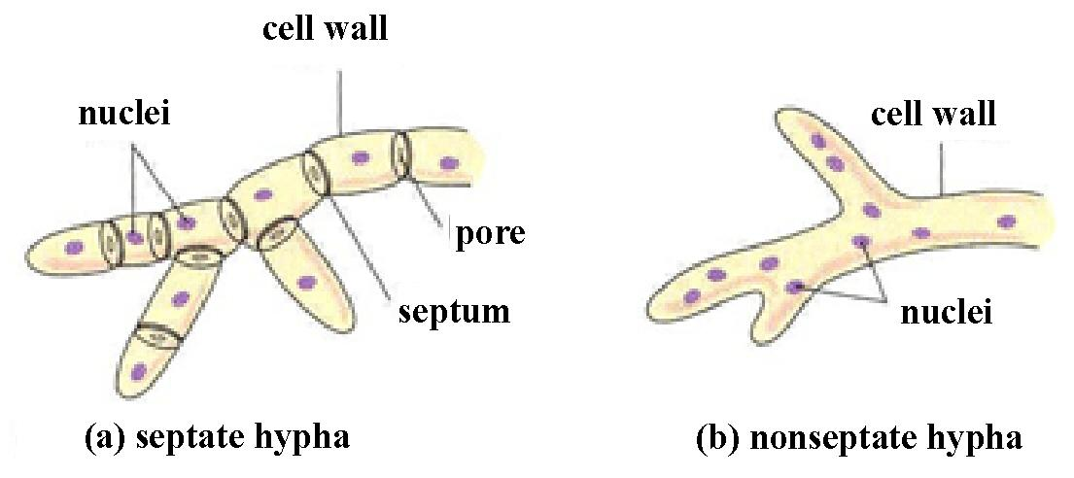
Fungi resemble algae in structure. They have a firm membrane consisting of cellulose, pectin substances, and carbohydrates. Another feature of fungi is the presence of chitin in their cell walls . The chitin adds rigidity and structural support to the thin cells of the fungus. Various inclusions are found in the cytoplasm: glycogen, volutin, drops of fat.Yeasts are fungi that grow as solitary cells that reproduce by budding. Yeast taxa are distinguished on the basis of the presence or absence of capsules (exception - Cryptococcus neoformans), the size and shape of the yeast cells, the mechanism of daughter cell formation (conidiogenesis), the formation of pseudohyphae and true hyphae, and the presence of sexual spores. Yeasts such as C albicans and Cryptococcus neoformans produce budded cells known as blastoconidia.
Fungi are usually classified according to biological taxonomy based upon the type of hypha, spore and reproduction. There are four classes of fungi.
Class Phycomycetes. The algal fungi: bread molds and leaf molds. The only known mycosis (fungal disease) caused by fungi of this class is mucormycosis, a very rare fungal growth of the upper respiratory tract, bronchial mucosa, and lungs. It occurs largely as a complication of a chronic, debilitating disease, such as uncontrolled diabetes.
Class Ascomycetes. The sac fungi: yeasts, mildews, and cheese molds. Fungi of this class are implicated in only three fungus diseases, all of which are rare.
The genus Aspergillus belongs to the class Ascomycetes. The fungi have divided septate mycelium, and a unicellular conidiophore which terminates in a fan-like row of short sterigmata from which the spores are pinched off in chains — conidia (Gk. konidion particle of dust).
A typical representative of aspergilla is Aspergillus niger which is widespread in nature. It is found on moist objects, on bread and jam. Certain species may cause aspergillosis of the lungs, ear, and eye in humans or may infect the whole body.
The genus Penicillium belongs to the class Ascomycetes. The mycelium and conidiophore are multicellular while the fruiting body is in the shape of a brush. The conidiophore branches towards its upper part and terminates in sterigmata from which even-rowed chains of conidia are pinched off. This genus of fungi is widespread in nature. It is found in fodder, milk products, ink and jam, on moist objects, and old leather. The type species is Penicillium glaucum.
Basidiomycetes, fungi with a multicellular mycelium. These organisms predominantly reproduce sexually by basidiospores (basi-dia — reproductive organs in which a certain number of spores develop, usually). Smut fungi invade grain crops causing a disease known as smut. Rust fungi affect sunflowers, and other plants. They produce orange-coloured sports on infected plants.
Deuteromycetes (Fungi imperfecti) are a rather large group of fungi consisting of a multicellular mycelium without either the asco- or basidio-sporangiophore, but only with conidia. Reproduction is asexual, sexual reproduction is unknown.

Morphology and Ultrastructure of Protozoa.
Protozoa (Gk. protos first, zoon animal) are unicellular animal organisms more highly organized than bacteria. They have a cytoplasm, a differentiated nucleus, a cell wall which differs in optical properties, and primitive organelles.
Protozoa reproduce by simple and multicellular division, sexually, and also by a more complicated process — sexually and asexually (malarial plasmodium). Three types of locomotory organelles may be present. One or more long flagella may be present. Cilia, shorter and more numerous than flagella are present in some taxa. Flagella and cilia aid in swimming. Pseudopodia, temporary extensions of the cytoplasm which elongate the plasma membrane, permit enable crawling.
Most protozoans pass through at least two distinct morphological forms during their life cycle. Much of the terminology for these forms is specific to particular taxa. Some terms are fairly general. Feeding stages are termed trophozoites, and these may reproduce asexually. Trophozoite (Greek for “animal that feeds”) is a general term for the active, feeding, multiplying stage of most protozoa.Transmission stages enclosed within a membrane to resist conditions in the external environment are called cysts. Stages which are about to reproduce sexually and form gametes are called gametocytes. Amoebae, lamblias and balantidia can produce cysts. 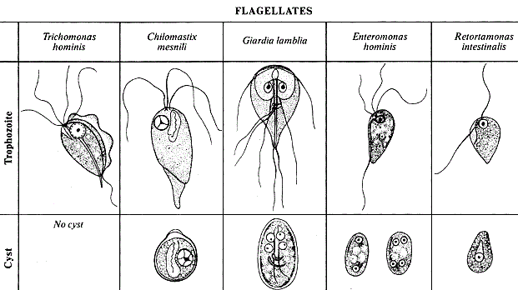
The basic body organization of protozoans consists of an external plasma membrane which encloses the cytoplasm and nucleus . There may be one or more nuclei, and in some taxa the nuclei are of two types: larger macronuclei and smaller micronuclei.
Organelles present within the cytoplasm that are visible by light microscopy are few. Vacuoles containing food material in various states of digestion may be present, and mitochondria are occasionally large enough to be seen. Representatives of certain species have two or more nuclei. The phylum Protozoa can be subdivided into 5 classes: Flagellata, Sarcodina (Rhizopoda), Apicomplexa, Microspora, Ciliophora.

Morphology and classification of viruses
The name virus (L. virus poison) was given by Pasteur to many causative agents of infectious diseases and by Beijerinck to the causative agent of tobacco mosaic disease.
Viruses are small obligate intracellular parasites, which by definition contain either a RNA or DNA genome surrounded by a protective, virus-coded protein coat . The cell wall or the special surface membrane has been named a capsid as it is composed of a certain amount of capsomers. The number of structural capsomers in the capsid of a given virus is constant (32 in the poliomyelitis virus, 252 in the adenovirus, 2000 in the tobacco mosaic disease virus, etc.). A complete virus particle is called a virion. The main function of the virion is to deliver its DNA or RNA genome into the host cell so that the genome can be expressed (transcribed and translated) by the host cell. Viruses do not have a cellular structure and are small in size, varying over a wide range from 20 to 350 nm.
The viral genome, often with associated basic proteins, is packaged inside a symmetric protein capsid. The nucleic acid-associated protein, called nucleoprotein, together with the genome, forms the nucleocapsid. In enveloped viruses, the nucleocapsid is surrounded by a lipid bilayer derived from the modified host cell membrane and studded with an outer layer of virus envelope glycoproteins.

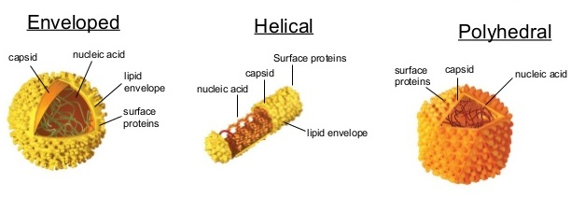
Viral structure and shapes

The size of viruses can be determined by filtration through colloid membranes, centrifugation in high-speed centrifuges, and electron microscopy.
Symmetry (the property of bodies to repeat their parts) is an important feature in the structure of virions. Viruses have no enantiomorphic protein molecules, their symmetric packings have only axes of symmetry. A symmetry axis is a straight line on rotation about which to a definite angle a figure coincides with itself. According to the character of the packing of the protein subunits, viruses are subdivided into two types of symmetry: spiral and cubic. In spiral symmetry the packing of the subunits turns into a closed cylindrical pattern. In cubic symmetry the lines of the curve of the tightly packed hexagonal subunit layer will be straight lines stretching at an angle of 120 degrees in relation to one another. The elements of the surface are equilateral triangles.
A single-strand RNA molecule is located between protein subunits. The viruses of influenza, parainfluenza, and others and others belong to the spiral type of symmetry.
Viruses with cubic symmetry have the shape of a polyhedron (tetrahedron, hexahedron, dodecahedron, icosahedron); these are the causative agents of poliomyelitis, papilloma, and herpes, adenoviruses, etc.
Some viruses are marked by combined symmetry, having an intermediate layer ('inner' capsid) possessing a different type, between the 'outer' capsid and the nucleoid; certain phages (T2, T4, T6), the vaccinia virus, etc. belong to this group.
In a number of virus infections intracellular inclusions are formed. Many of them are well discerned under a light microscope, and they are employed for laboratory diagnosis of rabies, smallpox and other diseases.
Viruses are obligate parasites. They live and multiply in the cells of live organisms (lower and higher plants, arthropods, wild and domestic animals and man), but are also able to develop in homogenates of different tissues and organs.

Property | Viruses | Cells
Type of nucleic acid | DNA or RNA but not both | DNA and RNA
Proteins | Few | Many
Lipoprotein membrane | Envelope present in some viruses | Cell membrane present in all cells
Ribosomes | Absent | Present
Mitochondria | Absent | Present in eukaryotic cells
Enzymes | None or few | Many
Multiplication by binary fission or mitosis | No | Yes
Figure 59. Comparison of viruses and cells

Morphology. Viruses are grouped on the basis of size and shape, chemical composition and structure of the genome and mode of replication. Helical morphology is seen in nucleocapsids of many filamentous and pleomorphic viruses. Helical nucleocapsids consist of a helical array of capsid proteins (protomers) wrapped around a helical filament of nucleic acid. Icosahedral morphology is characteristic of the nucleocapsids of many “spherical” viruses. The number and arrangement of the capsomeres (morphologic subunits of the icosahedron) are useful in identification and classification. Many viruses also have an outer envelope .
Chemical Composition: The genome of a virus may consist of DNA or RNA, which may be single stranded (ss) or double stranded (ds), linear or circular. The entire genome may occupy either one nucleic acid molecule (monopartite genome) or several nucleic acid segments (multipartite genome). The different types of genome necessitate different replication strategies.
1. Spherical form. This includes the viruses of influenza, parotitis, Japanese encephalitis, measles, arboviruses and other viruses. The size of viruses having a spherical shape varies within the range of 18 to 150 nm.
2. Rod-shaped form. This includes the causative agents of tobacco mosaic disease, potato blight, etc. They are 300 nm in length and 15 nm in width.
3. Cuboidal form. This form is characteristic of the vaccinia (cowpox) virus, the viruses of smallpox and papillomas of humans and animals, adenoviruses, enteroviruses, reoviruses, etc. Their size ranges between 30 and 350 nm.
4. Spermatozoid form. It is characteristic for viruses of the lower plants (phages). Their size varies from 47-104 to 10-225 nm.

